Queue implementation in JavaScript.
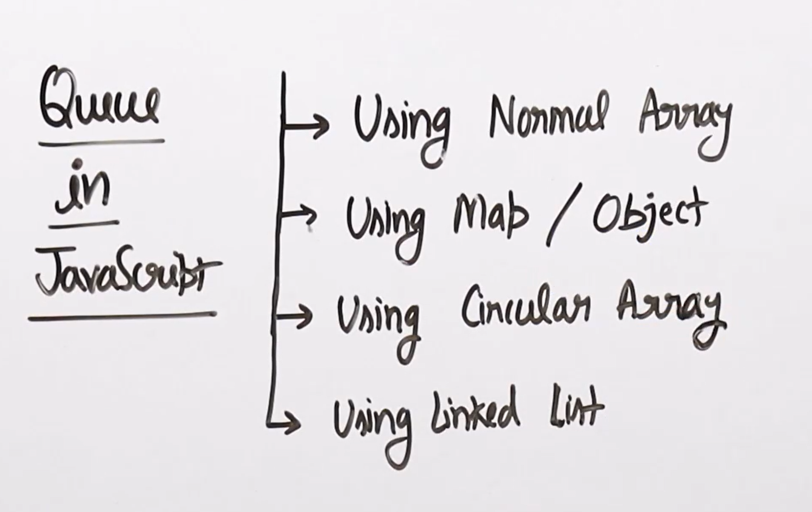
This below implementation is not recommended to use why means dequeue take O(n) time complexity take.
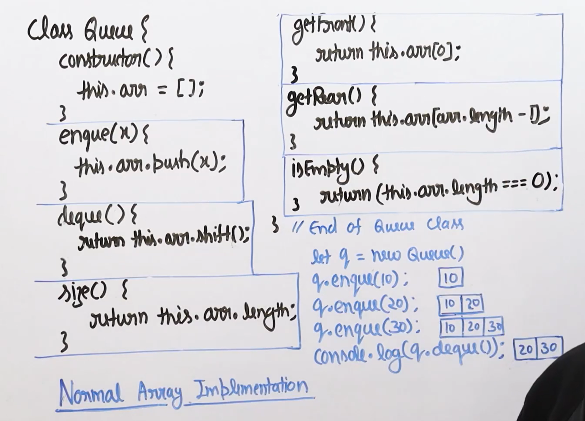
These is the implementation by using the map and the objects in the JavaScript.


